About Alpine Mountain Huts:
Facilities, services, etiquette

An overview of what mountain huts and rifugi are, how and when they operate, and why they are so special.

Modified by R. Rutz from http://www.touchingnature.co.uk/alpine-hut-information.htm and other sources and personal experience. v.2, Nov. 2017
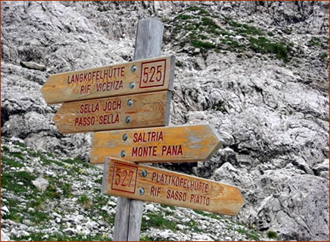
The Alps are home to a large number of mountain huts and rifugi which provide basic accommodation and, in many cases, food and drink. These rustic buildings are often situated in the most stunning locations: perched high above the crowded resorts, they offer spectacular views and serenity. For visitors new to the area, the hut system can at first seem confusing, but once you understand how the system works, you will undoubtedly enjoy making good use of these very useful and welcoming establishments.
N.B. Mountain huts exist across the entire Alps range, but the following information applies specifically to the hut and rifugio networks in Austria, Switzerland, Germany, Liechtenstein or the Italian Dolomites and South Tyrol (Alto Adige/Südtirol) region.
What are Mountain Huts?
If you come across the term “hut-to-hut walking”, it will almost certainly be in relation to the Alps. Alpine huts were originally built as basic overnight accommodation for serious mountaineers who needed to take respite when tackling their chosen peak. Over the years, this network was gradually extended to make them available to walkers as well and now it is just about possible to traverse the Alps from one end to another, using these places as stopping-off points. Depending on which country they are officially located in, you may see such a place referred to as a Hütte, Berghütte, cabane, chamanna, refuge or rifugio.
The mountain huts and rifugi are usually very well built and maintained. Some huts are operated by mountaineering clubs, while others may be privately owned (but still open to all). Huts are usually hours or even days away from the closest road, though some may be accessible by special taxi service. The overnight facilities are usually basic, consisting of either bunk beds or a mattress room(s) and rudimentary washing and toilet facilities. (However, a number of huts are developing some rooms in which 2-6 people may stay in bunk-type beds. Also, some larger huts at lower altitude may offer better menus and lodging. You may even have the luxury of a hot shower!) As a general rule, the higher the altitude, the more rustic you get. Some locations are unstaffed, and some have very rudimentary facilities and services; but the ones you’ll be interested in are fully staffed (bewirtschaftet), which means they also serve food and drinks.
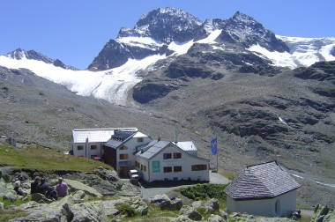
Mountain inns, run independently from the hut network and normally found at lower altitudes, usually offer a higher level of comfort. You may see such a place referred to as an Alm or Bergalm, guest house/Gasthaus, Bed and Breakfast (B&B) or hotel garni, hotel or mountain hotel (Berghotel).
Mountain huts and rifugi vary in size, generally sleeping between 20 and 200 people. They are usually inexpensive places to stay overnight, although food and drink tends to come at a premium (mainly due to the difficulty involved in transporting the goods), compared with the cafés and bars in local villages and towns. Food might be delivered to the huts via all-terrain vehicle, cable lift (“materialbahn”) or even horse packers, backpackers or helicopter.
Huts are run by a warden and small staff team, and are usually open for the summer season from mid-late June until late September/early October. Increasingly, huts are trying to open during the winter holiday period in December/January. Some huts also have a room for mountaineers which stays open all year round. (It won’t be staffed but will provides a basic place to sleep.) Anyone using the mountains for recreational purposes can have access to the huts, but during busy times priority will be granted to members of the Alpine Clubs.
Mountain huts are really sociable and a great way to meet fellow hikers and mountaineers. You can relax, rest, have a beer on the sun-lit terrace while gazing at the incredible mountains and valleys nearby. But of course the greatest advantage is that they allow you to sleep overnight at altitude, in the most incredible locations, enjoying nature at its finest—wonderful views and scenery, clear starry nights and spectacular sunrises and sunsets. (Or, in bad weather, a warm, dry place to stay!)

Mountain Hut Etiquette

There are some simple rules which make the hut-to-hut hiking experience better for everyone.

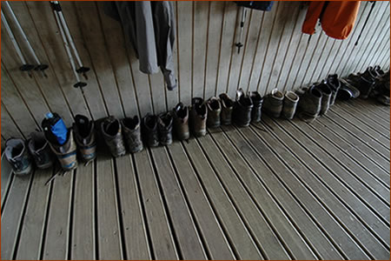
There is a clear and simple etiquette to using the mountain hut system, which is based on honesty and respect.
Reservations. It is best to make a reservation if possible, and be sure to arrive on time. Alpine huts in Austria, Switzerland and Bavaria, and huts and rifugi in the Dolomites and South Tyrol and other nearby areas can get very busy, and even large ones can fill completely on some nights. A few may require a deposit.
Boots and gear. When you arrive, you should take off your dirty boots in or near the entrance. Boots, poles, crampons should be left in a designated area on the porch or in a shoe/gear room. There is usually a rack or set of niches in which to place the boots. Don’t wear these in the communal or sleeping rooms, not even if you’re just stopping off for a quick snack. It’s a matter of cleanliness. Some mountain huts will provide special shoes for wearing indoors, but many hikers prefer to take their own lightweight slippers. Thick socks are also OK.
Wet gear. Most huts have a room or place (“trockenraum”) for hanging and drying wet gear. Use this if available.
Check-in. When you arrive you should register/check-in with the staff/hut warden: if traveling in a group, the group leader will usually do this for the group. Hut staff will allocate you a bed space(s)—which may be determined by what time you plan to get up in the morning, by the size of your group, or if you’ve paid extra for upgraded lodging. It is worth arriving by mid- to late afternoon in order to secure your space.
If you have an Alpine Club membership, you need to show your card for the reduced lodging rate (usually a savings of approx. $10). It is a good idea to mention your half board (“halbpenzion”) meal arrangement at this time, too: you may need to specify which of two or three meal options you want.
(In some cases you’ll also be asked to sign a visitors’ book, which will keep a log of where you came from and where you are heading to. Wardens check with one another that their guests have arrived as intended, in the more remote locations or in extreme weather conditions. Therefore, if your plans do change for any reason, be sure to advise the wardens to prevent an unnecessary search party.)
Packs and Rucksacks. In most huts, if you are staying there overnight you can bring your pack to the sleeping room. Brush it clean of dirt or grass before carrying it in. In a few huts you may or may not be allowed to take your rucksack into the sleeping room: in this case, you’ll normally be given a basket in which to put your overnight essentials (i.e., flashlight, toiletries, sleepwear, book, personal valuables).
Water Use. Remember that water is precious in these locations, so try to conserve water in washing and showering.
Meals.
At morning and evening meals you should be considerate of your fellow diners and come to the table washed and in clean clothes. Particularly when in hotels, restaurants and inns, long pants and a shirt/blouse should be worn (i.e., no shorts or T-shirts/tank tops).
Don’t take food from the table for eating on the hike! Especially, don’t take breakfast food to cover lunch. To provide for lunch, either pay for a picnic lunch to be packed for you, or stop at a hut along the way for a meal.
Huts can get very busy, so you should always be considerate of your fellow hikers. Small gestures such as clearing away your food waste to make space for someone else, will be appreciated. Some huts are self-service from a kitchen counter (“Selbstbedienung” in German-speaking areas).
If the trip is covering your lodging and dinner, you will still need to settle your own lunch, snacks, and drinks bill. It’s always a good idea to settle your bill before you go to sleep (some huts require that you do this). This will save you a lot of time in the morning. Some huts—but not all—will accept credit cards.
Sleep Etiquette. The most important rule in the hut is to respect other people's need for sleep!
• Sleepsack. Everyone must use a sleepsack in the huts! This is matter of hygiene, and the huts are very strict about this. It consists of sheets (or a lighter material) that are sewn together to form a rectangular sack, with a pocket at the top where you put the little pillow. This keeps the beds and pillows and blankets clean. There are several brands that you can purchase which are made of silk, which is superlight, cool when it’s hot, and adds a layer when it’s cool.
• Prepare for sleep ahead of time! Get your bedding (sleepsack) ready, and arrange your pillow and blankets. Of course you can’t pre-position anything that you’re using at the moment (such as slippers), but everything else should be prepared. Get out what you need for the night, including for making night-time trips to the toilet down the hall: flashlight, sweater, medications, ear plugs, eye mask. If there’s anything that you’ll want which is in a plastic bag—Take it out of the bag! Searching in your pack and rustling in those plastic bags makes an incredible amount of noise at night. Some people may retire very early: if you’re sleeping in a room with people you don’t know, get your area arranged before 9:00 pm.
• After Lights-out. The lights in the sleeping areas are usually turned off around 10:00 pm; the hut staff can tell you the time at check-in. In some rooms, people may turn them out earlier. The quiet time, or “Hüttenruhe”, extends from 10:00 to 6:00. Once the lights are out, don’t talk or make any unnecessary noise. If you have to get up to use the toilet, try and do it as quickly and quietly as possible. In a hut with a lot of people, it’s likely that there will be some people who stay up later than your group and come in after you’ve settled in: hopefully they will be polite, too.
• In the Morning. If your hut has a popular climbing peak nearby, it’s likely that at least one group in your hut will be a climbing group. Climbers like to make an early start (which could be as early as 2 a.m.): often, the hut will have a special early breakfast for them at about 6:00 a.m. N.B. Early to rise also means that some of the climbers may retire early the night before! Huts like to separate the climbers to minimize the timing conflicts.
Any time after 6:00 a.m., some people will start to get up. Breakfast usually starts at 7:00 a.m.
Camping or bivouacking. Camping nearby a hut, but using its facilities, is not allowed. Bringing your own lunch, but using hut seating and facilities, is also impolite or forbidden. Most of the land in the Alps is in private ownership, and unlike the National Forests in the U.S., camping is prohibited.
Garbage and Rubbish. Don’t dump your rubbish in the huts: it’s costly to transport things to or from the hut. You need to take it with you, until you can dispose of it responsibly in a village or town.

Alpine Hut Facilities and Services

Rifugio and mountain hut facilities: sleeping arrangements, food and refreshments, and bathroom amenities on a hut-to-hut trip in the Alps
The alpine huts that are staffed offer food and drink as well as lodging. As a general rule, the more remote the hut, the less well equipped it will be.
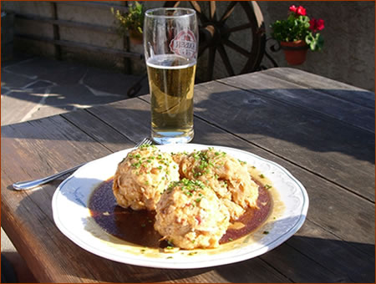
Food
Meals are usually simple and filling—designed to restore energy in tired walkers! A half-board (Halbpension) meal plan will include dinner and breakfast. This will be cheaper in cost and simpler than ordering à la carte. However, it will be either a set menu or with only few options. Huts are more likely in recent years to offer vegetarian options, but not all do this. Check on vegetarian or other food limitations (gluten-free, nut-free, etc.) and arrange for them ahead of time. Some huts pride themselves on offering fancier foods, but these will generally only be available à la carte.
Breakfasts and dinners are served at set times—you will need to check with the staff about these. Mealtimes are very social occasions, with lots of banter between walkers, climbers and mountaineers from around the world.
Some places can also provide you with a packed lunch (Picknick, pique-nique) on request for an additional charge. This may be specially prepared, or may simply be the meat, cheese and bread from breakfast.
Drinks
Drinking water is normally free of charge—unless you are in one of those rare locations where you must use bottled water. Other drinks such as tea, coffee, beer, wine, hot chocolate, mineral water, juices, etc. can usually be purchased at the hut. Especially in German-speaking areas, beer may be the least expensive drink! Skiwasser is a flavored water; Teewasser is a container of hot water in which you can use your own tea bags that you’ve brought with you.
If you are just traveling through, but need a refill of drinking water, huts are supposed to supply this for free: ask at the hut where Trinkwasser can be obtained.
Toilets, Wash Rooms, Showers
Normally there will be communal wash rooms, which consists of anything from modern sinks to little more than wash basins. Nearly all huts separate men’s and women’s washroom and toilet facilities. Some huts may offer the luxury of hot water, but normally it’s a case of bracing yourself for rather cold water.
In recent years, as many huts have tried to upgrade their facilities, showers have become more common. They may vary from several stalls to one large communal shower. Where available, showers usually cost money and have a limited time of 3–5 minutes for hot or warm water.
Accommodations
N.B. Men and women (and children, if any) all share these sleeping spaces together!
You will be allocated your sleeping space by the hut staff at the time of check-in. Sleeping areas are of several types. 1) The cheapest accommodation is the mattress rooms (Matratzenlager, or “lagers”). Typically, there will be 12–60 mattresses in a room. They may be arranged as a row or two of mattresses laid out side-by-side on the floor, or on one or several shelves. 2) A step up is a bunk room with 12–30 places, usually arranged side-by-side. Some bunks may be three levels high. 3) Some huts may have individual rooms (with bunks for 2–6) available for a higher price.
During peak times, these dorms can become really quite crowded and even stuffy. This is when the hut etiquette and politeness really help to make the experience better.
If a hut is at capacity, you could even find yourself relegated to an emergency space, which might be directly on the floor or on a tabletop in the eating area, or in one of the corridors. However, such overcrowding is rare. (If your trip will be largely a hut-to-hut trek, you might consider joining an Alpine Club, both for the lodging discount and the priority it would give you should the hut be at or near capacity.)
N.B. It’s helpful, perhaps essential for some people, to have several pairs of earplugs, and an eye mask (like some airlines will give you on overseas flights) when staying in the huts. Snoring and various rustlings are a fact of life, and these little accessories may greatly improve the quality of your sleep.
Bedding
Up in the mountains it can get very cold at night. Blankets (usually 2–3 wool) and a small pillow will be supplied to each person, but you must bring your own sleepsack/sleepsheet with pillow pocket. The lightest ones are made of silk. In some mountain huts, the blankets will have the word Fußende (= foot end) labelled.
Electricity
Electricity is normally available, but outlets may be limited. Supplies are usually very low, so don’t count on having a source for electric shavers (bring a rechargeable one) or phone charging. Most huts will conserve energy by switching power off at night, so you will need to use your flashlight to get around after dark.

